Vocabulary for The Glass Menagerie

1. Implacable: unable to be placated (appeased)
2. Tenement: A room/rooms that form a separate residence in a house; a block of apartments
3. Portiere: (PORE dee er) a curtain hung over a doorway
4. Masticate: to chew
5. Elegiac: (el a JAY ik) wistfully mournful
6. Elegy: a poem of serious reflection, typically a lament for the dead
7. Beaux: boyfriend or male admirer
8. Kitchenette: a small kitchen or part of a room equipped at one
9. Martyr: a person killed for religious or other beliefs; exaggerating pain to get sympathy
10. Specter: something widely feared, e.g. a ghost or nuclear holocaust
11. Cow-lick: hair that grows in the wrong direction and resists being tamed
12. Matron: a married woman
13. Sublimation: diverting unacceptable behaviors to those more acceptable
14. Subliminal: unconscious mental process
15. Relic: old objects, esp. of historical interest; part of a dead holy person’s body or belongings
16. Patronage: support, often with the power to control, sometimes condescending
17. Insolence: rude
18. Aghast: horrified or shocked
19. Pinion: tie or hold someone’s arms or legs, a bird’s wing as used in flight
20. Avert: Turn away (one’s eyes or thoughts); prevent something from happening
21. Solemn: formal and dignified
22. Bower: a pleasant shady place under trees or climbing plants
23. Endowment: income or property given or bequeathed
24. Bequeath: an inheritance
25. Dismal: depressing, dreary
26. Fiasco: complete failure, esp. in a ludicrous or humiliating way
27. Importunate: (im POR che net) troublesomely urgent, overly persistent in request or demand
28. Emulate: imitate
29. Imminent: about to happen
30. Bombardment: a continuous attack with bombs, shells, or other missiles
31. Demure: a reserved, modest, and shy woman
32. Veranda: a roofed platform outside a house, level with the ground floor; a type of porch
33. Supercilious: behaving or looking as though one thinks one is superior to others
34. Illuminate: make something visible or bright by shining a light on it; to clarify something
35. Eloquent: fluent or persuasive in speaking or writing, well-spoken
36. Velocity: the speed of something in a given direction
37. Unobtrusive: not conspicuous or attracting attention
38. Radiance: light or heat emitted or reflected by something
39. Cotillion: a formal ball, esp. one where debutantes are presented
40. Debutant: a person making a first appearance in fashionable society
41. Promenade: a leisurely walk with the intention of meeting or being seen by people
42. Sashay: walk in an exaggerated manner, swinging hips and shoulders
43. Mincing: purposely dainty
44. Giddy: dizzy or excitable and frivolous
45. Ominous: giving the impression that something bad is about to happen
46. Lyrically: expressing emotions in an imaginative and beautiful way
47. Imperious: assuming authority without justification; arrogant and domineering
48. Preposterous: utterly absurd or ridiculous
49. Incandescent: an object that glows at a high temperature, such as coal
Marquees: (mar KEY) a tall roof-like structure, often with a sign over an entrance (theater or hotel)
50. Vivacity: lively and animated in an attractive way
51. Paragon: a person or thing regarded as a perfect example of a particular quality.
52. Vestige: a trace of something that is disappearing or no longer exists
53. Tribulations: a cause of great trouble or suffering
54. Rhapsodic: (rap SOD ik) extravagantly emotional
55. Exposition: a public display or art or trade goods
56. Heigh-ho: usually an expression of boredom, occasionally of great joy
57. Wincing: reacting with a slight involuntary grimace or shrinking movement
58. Beleaguered: in a very difficult situation
59. Indolent: lazy
60. Tumult: confusion or disorder
61. Aptitude: a natural ability or tendency
62. Eclipsed: deprive someone or something of significance, power, or prominence
63. Perturbation: anxiety
64. Desolation: emptiness or destruction; anguished misery or loneliness
65. Tyranny: Cruel and oppressive rule 66. Jaunty: confidently lively and cheerful
67. Sphinx: Egyptian stone figure with a lion’s body and a human or animal head*
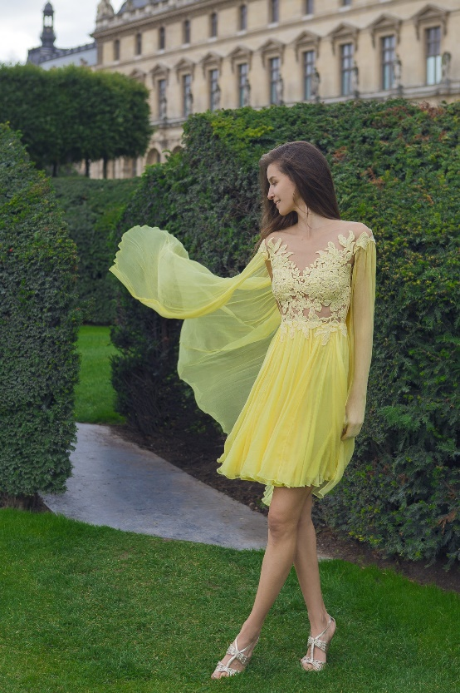

68. Voile: A thin, semitransparent fabric of cotton, wool or silk
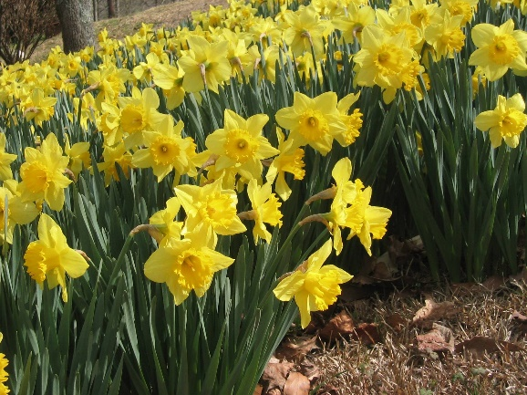

69. Jonquils: small fragrant yellow flowers * Sphinxes, represented in various shapes and forms, were not only part of Egyptian culture. They were also common throughout the ancient Middle East and Greece. In Greek mythology and art, the Sphinx was a winged monster with the head and breasts of a woman and the body of a lion. In the legend of Oedipus, she acts as a destructive agent of the gods, presenting this riddle: “What walks on four feet in the morning, on two at noon and on three in the evening?” She killed all who failed to answer. Oedipus solved the riddle thus: “Man crawls on all fours as a baby, walks upright in the prime of life and uses a staff in old age.” After the riddle was solved, the Sphinx killed herself.

