To Kill a Mockingbird by Harper Lee
Vocabulary and Research

1. Beadle: a ceremonial officer of a church, an officer of the church who assists the minister, a low-level officer of the church dealing with those who commit petty (small) offences.

2. Ramrod: a rod for ramming down the charge of a muzzle-loading firearm. The charge is the chemical substance that produces the energy that forces out the bullet. The ramrod is the stick below the gun.

Because of the use of this tool, the word also came to mean forcing an idea into acceptance or immediate and fast completion.

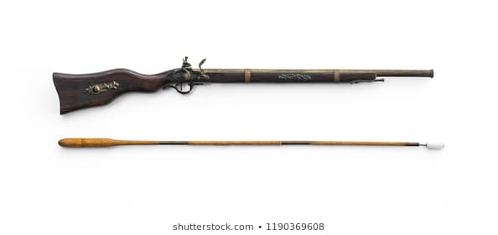

3. Sawhorse: a frame that supports wood for sawing

4. Tom Swift: Tom Swift is the main character of five series of American juvenile science fiction and adventure novels that emphasize science, invention, and technology.

Tom Swift and his Wizard Camera (1912) features a portable movie camera, not invented until 1923.

Tom Swift and His Electric Locomotive (1922) was published two years before the Central Railroad of New Jersey began using the first diesel electric locomotive.

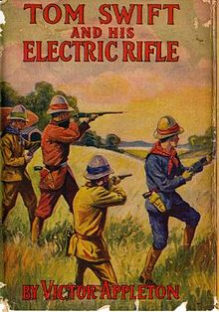

5. Corset: a woman’s tightly fitting undergarment that started under the bosom and extended down over the hips. It was worn to shape the figure.
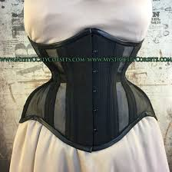

RESEARCH TOPICS

1. General Jackson – Who was he? What were his policies toward Native Americans?

2. The Battle of Hastings—What important end result came from this? When did it occur?

3. Cornwall—Where is this? What can you tell us about it?

4. John Wesley—Who is he? What profession was he in? In what ways did he influence Methodists? Why were they persecuted?

5. First and second degree murder—What is the difference?

6. “We have nothing to fear but fear itself”—What famous person said this? When? Where? Why?

7. The Great Depression—What caused it? What ended it? What is the stock market?

8. Jim Crow Laws—What were they? Who created them and why?

9. NAACP—Define this and explain its importance.

10. The 13th and 14th Amendments—What are they? What are they supposed to do?

11. The Scottsboro Trials—What were they? What happened?

12. Lynching—What is it? How was this used in the U.S. as a way of controlling people?

13. Jury Trials—What is the purpose of this type of trial? Why is it important?

14. The Civil War—Why was it fought? What were the results of it?

15. The Missouri Compromise—What is it?

16. Reconstruction—What is it?

17. The WPA—What is this? What did it do?

18. The National Recovery Act—What is this? When was it set up? What did it do?

