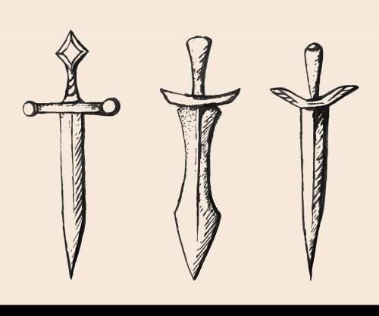

Hamlet Act 3: Hamlet’s soliloquy (123-24; 3.2.57-91)
To be, or not to be? That is the question—
Whether ’tis nobler in the mind to suffer
The slings and arrows of outrageous fortune,
60 Or to take arms against a sea of troubles,
And, by opposing, end them? To die, to sleep—
No more—and by a sleep to say we end
The heartache and the thousand natural shocks
That flesh is heir to—’tis a consummation consummation = to complete or finalize something
65 Devoutly to be wished! To die, to sleep. devoutly = a word heavy with Christian feeling
To sleep, perchance to dream—ay, there’s the rub, perchance = perhaps
For in that sleep of death what dreams may come
When we have shuffled off this mortal coil, coil = something wound
Must give us pause. There’s the respect
70 That makes calamity of so long life. calamity = disaster
75  80  85  90 | For who would bear the whips and scorns of time,  Th' oppressor’s wrong, the proud man’s contumely, contumely = a noun that means insult  The pangs of despised love, the law’s delay,  The insolence of office, and the spurns spurns = rejects  That patient merit of th' unworthy takes,  When he himself might his quietus make quietus = death or cause of death  With a bare bodkin? Who would fardels bear, bodkin = sharp instrument/needle for sewing  To grunt and sweat under a weary life, fardels -- bundles  But that the dread of something after death,  The undiscovered country from whose bourn  No traveler returns, puzzles the will  And makes us rather bear those ills we have  Than fly to others that we know not of?  Thus conscience does make cowards of us all,  And thus the native hue of resolution  Is sicklied o'er with the pale cast of thought,  And enterprises of great pitch and moment pitch = the height or depth of something  With this regard their currents turn awry, awry = amiss  And lose the name of action.—Soft you now,  The fair Ophelia!—Nymph, in thy orisons nymph = a beautiful maid orisons = prayers  Be all my sins remembered.  Hamlet Act 3: Hamlet’s soliloquy (123-24; 3.2.57-91)  To be, or not to be, that is the question:  Whether 'tis nobler in the mind to suffer  The slings and arrows of outrageous fortune,  60 Or to take arms against a sea of troubles  And, by opposing, end them. To die, to sleep—  No more—and by a sleep to say we end  The heartache and the thousand natural shocks  That flesh is heir to—'tis a consummation  65 Devoutly to be wished. To die, to sleep—  To sleep, perchance to dream. Ay, there's the rub,  For in that sleep of death what dreams may come,  When we have shuffled off this mortal coil,  Must give us pause. There's the respect  70 That makes calamity of so long life.  For who would bear the whips and scorns of time,  Th' oppressor's wrong, the proud man's contumely,  The pangs of despised love, the law's delay,  The insolence of office, and the spurns  75 That patient merit of th' unworthy takes,  When he himself might his quietus make  With a bare bodkin? Who would fardels bear,  To grunt and sweat under a weary life,  But that the dread of something after death,  80 The undiscovered country from whose bourn  No traveler returns, puzzles the will  And makes us rather bear those ills we have  Than fly to others that we know not of?  Thus conscience does make cowards of us all,  85 And thus the native hue of resolution  Is sicklied o'er with the pale cast of thought,  And enterprises of great pitch and moment  With this regard their currents turn awry  And lose the name of action.—Soft you now,  90 The fair Ophelia.—Nymph, in thy orisons  Be all my sins remembered.

