Death of a Salesman ACT 2

Consider the farming and building references in Act 1 and make note of them as you read Act 2.

Saccharine – relating to or containing sugar – Saccharin (without an e at the end) is artificial sweetener,
like Sweet ‘N Low.

1. Biff gets dressed in his blue suit to go downtown to see about securing a loan from Oliver. Based on what you learned in Act 1, predict how this meeting will go and explain your view. Respond to Linda’s comment after Willy asks how Biff dressed for this meeting?

2. Why does Willy get nervous when Linda mends her stockings (75)?

Valise – a small suitcase

Pennant – a flag denoting a sports championship or other achievement

Casino – a card game

https://www.profootballhof.com/players/harold-red-grange/
Red Grange – Harold Edward "Red" Grange, nicknamed "The Galloping Ghost." was an American football halfback for the University of Illinois, the Chicago Bears, and for the short-lived New York Yankees. His signing with the Bears helped legitimize the National Football League.

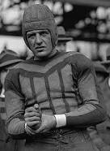

J. P. Morgan – John Pierpont Morgan (1837-1913) was an American financier and banker who dominated corporate finance and industrial consolidation in the US in the late 19th and 20th centuries

Hackensack – a city in New Jersey, near New York City

Archly – deliberate and often forced playfulness or impudence

Implacably – unable to be placated; relentless, unstoppable

Barrelhead – the flat top of a barrel; Willy means that one barrelhead is worth $20,000. He is referring to his life insurance and he is the barrelhead. He is a commodity.

Gilt edged – covered thinly with gold leaf or gold paint, of the best quality, expensive, valuable
Gild and gilt both mean “making something beautiful”; to gild is the action of covering something with a thin layer of gold; that action results in the gilt. Gilt is an adjective or a noun. Gild is the verb. 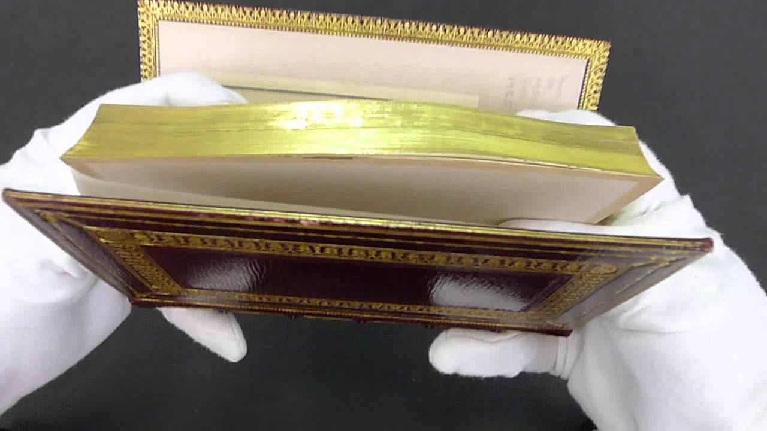

Coolie – unskilled laborer in India, China or other Asian country; originally this meant indentured, later it
just meant someone working for subsistent wages
Subsistent – lowest level of supporting oneself
Indentured servitude – to be bound by legal contract to apprenticeship or labor for a certain number of
years in exchange for transportation and necessities of life

Premium – the cost of having an insurance policy, the monthly bill

On the nose – exactly

3. Consider the ways in which Willy refers to himself as a commodity when he speaks to Ben (starting on page 125). Explain the author’s intention with this extended metaphor.

4. Willy says, “He’ll see what I am, Ben! He’s in for a shock that boy!” (126). Who is the boy? What does Willy expect him to learn?

Regarding Biff, Happy starts to say something but stops. What he manages to utter is this: “You crazy—” (130). The complete, common expression would be this: “You crazy son of a bitch.”

When Biff refers to Happy as “a big blow” (131), he means a big blowhard. A blowhard is an unpleasantly boastful person.

A dime a dozen (132) – things that are abundant in quantity and/or very cheap; something easily acquired

Drummer – a traveling sales representative, one who drums up business; during the 1800’s in the US, especially during the Civil War of 1861-1865, traveling salesmen kept their wares in a leather-clad box that was essentially a wooden frame with leather stretched over it. This structure created a sound like a muted snare drum.

Elegiacally – done like in a poem of serious reflection, typically a lament for the dead

THE REQUIEM

Requiem – a Mass for the repose of the souls of the dead

5. Between Charley and Biff, who understands Willy better?

Motif – an idea, an object, a concept, a character archetype, the weather, a color, or even a statement, used to establish an idea, mood, theme or lead to symbolic meaning.

6. Provide 3 or more quotes that reflect a single motif. Comment on the meaning of this literary device.

7. Name a theme and provide three examples that support your assertion.

