NOTES 23: “The Rime of the Ancient Mariner” by Samuel Taylor Coleridge

In order to develop a foundation upon which to build, read this page and links before accessing the poem in Norton on page 1615-32.

To have an albatross around your neck indicates a burden of guilt that hinders your success.
Some think this adage suggests only an annoying burden of any sort, which is inconsistent with the poem.

Process and Interpretations: www.bl.uk/romantics-and-victorians/articles/an-introduction-to-the-rime-of-the-ancient-mariner

Synopsis: (Encyclopaedia Britannica www.britannica.com/topic/The-Rime-of-the-Ancient-Mariner)
The Rime of the Ancient Mariner poem in seven parts by Samuel Taylor Coleridge that first appeared in Lyrical Ballads, published collaboratively by Coleridge and William Wordsworth in 1798. The title character detains one of three young men on their way to a wedding feast and mesmerizes him with the story of his youthful experience at sea—his slaughter of an albatross, the deaths of his fellow sailors, his suffering, and his eventual redemption.

On an icebound ship near the South Pole, the mariner and his crew are visited by an albatross, considered a favourable omen. The ship breaks free of the ice and sails north, followed by the giant bird. Then, inexplicably, the mariner shoots and kills it, bringing a curse upon the vessel. After some confusion, his shipmates vilify him and hang the bird carcass around his neck. The passing of a ghost ship (a bad omen) presages the deaths of all aboard ship except the narrator. Lost and alone, he marvels at a life-affirming vision in the moonlight, and his prayer of reverence causes the albatross to fall into the sea. Following his rescue, the mariner understands that his penance for his destructive act will be to wander the world recounting his awful story.

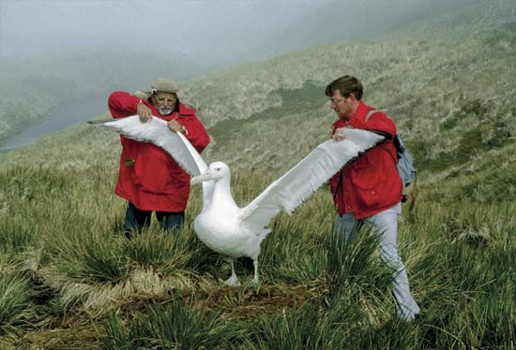
Seamen once held albatrosses in considerable awe; they held that killing an albatross would bring bad luck, a superstition reflected in Samuel Taylor Coleridge’s poem “The Rime of the Ancient Mariner.” In spite of this superstition, the birds were often taken on baited hooks by sailors for meat. The foot web could be fashioned into a tobacco pouch, and the long hollow bones were used as pipe stems. At one time professional plume hunters even raided breeding grounds. The North Pacific species were slaughtered in large numbers for their feathers, which were used in the millinery (hat) trade and as swans down. www.britannica.com/animal/albatross/media/12596/161773
_____________________________________________________________________________________________________________
ASSIGNMENT

Part 1: Pull at least 5 images throughout the poem and record a possible symbolic or metaphoric meaning.
To facilitate discussion, note the locations of the images in one or several places.

Part 2: Create three questions to ask of your discussion partners.
Saved as: AP Lit NOTES 23 Rime

