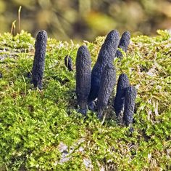
These might be the “long purples” Gertrude refers to when discussing Ophelia’s death (164; 4.7.172).

A coronet of flowers (4.7.175)

