A Raisin in the Sun
Lorraine Hansberry (1930-1965)

SETTING: “The action of the play is set in Chicago’s Southside, sometime between World War II and the present,” which was first produced in 1959 (1522).

Act I Scene I (1523-40) 17 pages
1. Why does Walter have to wait for Mr. Johnson in order to use the bathroom? Who is Mr. Johnson?

2. Walter is described as “a lean intense young man in his middle thirties, inclined to quick nervous movements and erratic speech habits—and always in his voice there is a quality of indictment” (1524).
What does this suggest?

3. What do you glean about Ruth and Walter’s relationship from their morning interaction (1525)? What is Ruth mad about?

NOTE: Walter tells Ruth, “First thing a man ought to learn in life is not to make love to no colored woman first thing in the morning. You all some evil people at eight o’clock in the morning” (1525). At this time, the term “making love” did not mean having sex.

4. Explain the interaction regarding the money Travis asks for. What are the dynamics between all the players in this scenario (1526-27)?

5. Explain Beneatha’s attitude (1530-33).

6. When talking to Ruth about helping Walter buy a liquor store, Mama says, “Well—whether they drinks it or not ain’t none of my business. But whether I go into business selling it to ’em is, and I don’t want that on my ledger this late in life” (1534). What is the ledger she refers to?

7. What do we learn about Big Walter from Lena’s description (1535-36)? How does Lena feel about him? What do you think of him?

NOTE: Beneatha rankles Lena and Ruth with her flippant reference to scripture: “Well—if the salt loses its savor—” (1536).
From the King James version of the Bible – “Ye are the salt of the earth: but if the salt have lost his savour, wherewith shall it be salted? it is thenceforth good for nothing, but to be cast out, and to be trodden under foot of men” (Matthew 5:13).

8. What do you think of the way Mama handled Bennie for her sacrilegious comments? What do you think about Ruth’s handling of this incident?
9. Which character do you like the most? Why?

10. Which character will struggle the most? Why?

11. Which character will show the greatest degree of fortitude? Why?

12. Ruth does not seem well. What might be the problem?

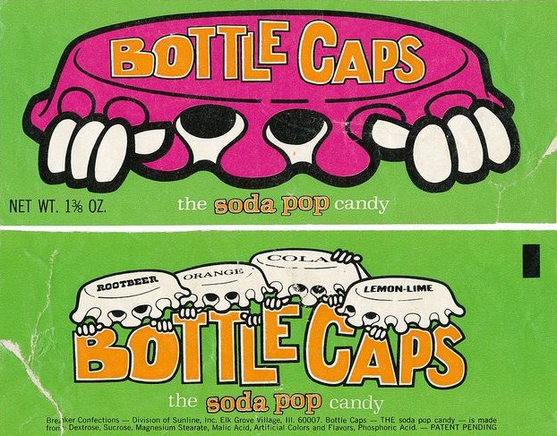

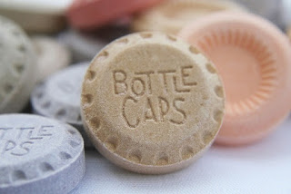

When Ruth tells Travis “now caps,” she probably means these candies. They were fizzy, like a carbonated drink, but they dissolved like sweet tarts.

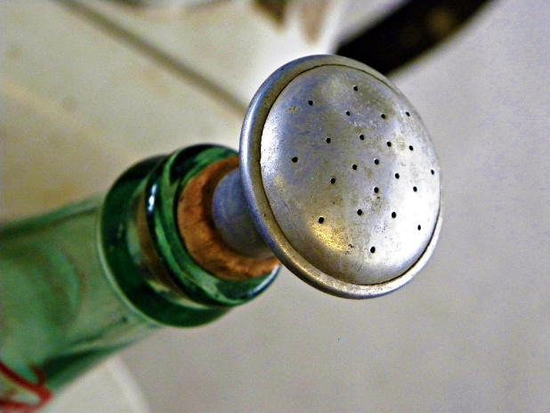

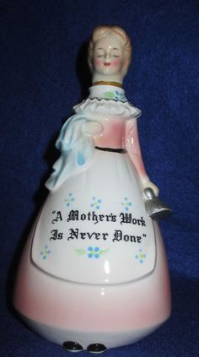
O

These are sprinkling containers. The first image is a 7Up bottle with a sprinkling cork inserted into the top. The second picture is a glass container that you fill with water by turning the container upside down. There are probably tiny holes on the top of this figurine’s head where the water droplets come out.

Women used to hang wet laundry on clothes lines outside to dry. They would become stiff because they fabric were cotton and linen. There was little in the way of knits or polyester. In order to soften clothes so they could be ironed, women would sprinkle them with tap water, roll the garment up tightly and stack the rolled clothes in a cool dark place so the sprinkles could dampen the clothe more evenly. Then, before the clothing got mildewed, they would iron. Everything got quite wrinkled. Women ironed sheets and pillow cases, too. Otherwise, the wrinkles made the sheets uncomfortable to sleep on.

Act I scene I (1523-40) 17 pages

Act I Scene II (1540-51) 13 pages

Act II Scene I (1551-61) 11 pages

Act II Scene II (1561-66) 5 pages

Act II Scene III (1566-77) 13 pages

Act III Scene I (1577-89) 13 pages

